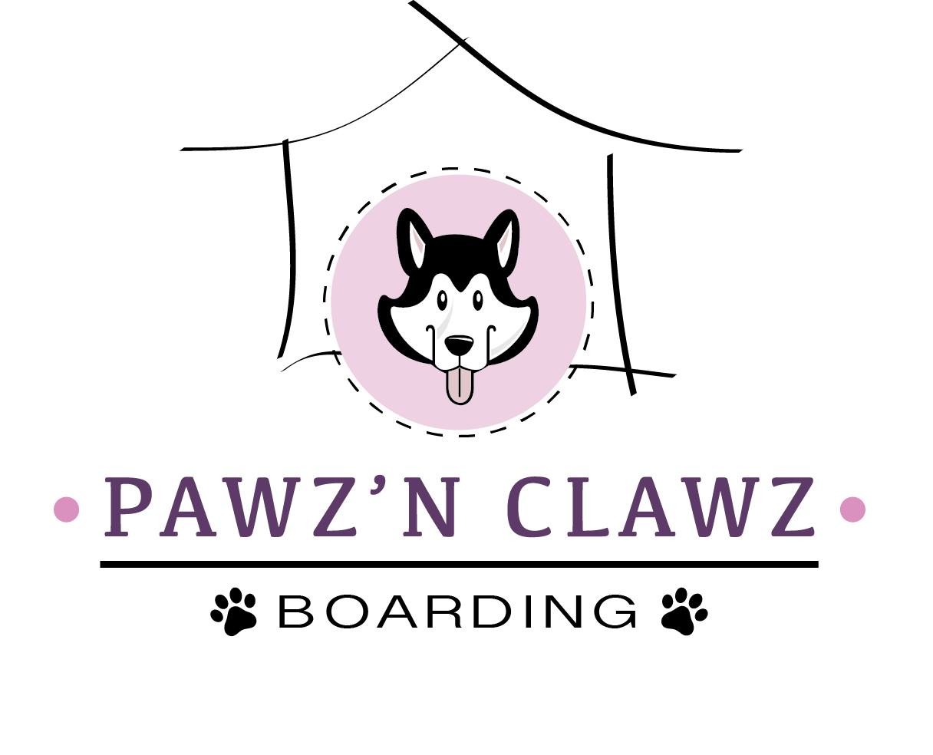
CANCELLLATION POLICY:
BECAUSE WE TAKE A LIMITED NUMBER OF PETS AND ONCE WE REACH OUR MAXIMUM WE BEGIN TO TURN AWAY OTHER CLIENTS AND OUR STAFFING IS BASED ON THE NUMBER OF PETS EXPECTED TO STAY WITH US SO WE RELY ON ALL THE RESERVATIONS MADE ESPICALLY DURING PEAK TIMES. WHEN A RESERVATION IS CANCELLED LAST MINUTE IT AFFECTS OUR DAILY BUSINESS.
WE ASK THAT YOU PLEASE READ THE FOLLOWING CANCELLATION POLICY. FEEL FREE TO LET US KNOW IF YOU HAVE ANY QUESTIONS.
WE REQUIRE 14 DAYS NOTICE FOR CANCELLATION OF ALL OVERNIGHT BOARDING BOOKINGS DURING OUR PEEK TIMES. PLEASE SEE THE FOLLOWING PAYMENT POLOCIES AND DATES IN AFFECT.
LESS THAN 14 DAYS NOTICE YOU WILL BE BILLED 25% OF THE TOTAL INVOICE.
LESS THAN 7 DAYS NOTICE YOU WILL BE BILLED FOR 50% OF THE TOTAL INVOICE.
LESS THAN 3 DAYS NOTICE YOU WILL BE BILLED FOR 75% OF THE TOTAL INVOICE.
LESS THAN 24 HOURS NOTICE YOU WILL BE BILLED FOR 100% OF THE TOTAL INVOICE.
*****ANY CANCELLATIONS MUST BE MADE DURING BUSINESS HOURS 7 AM – 6PM. IF PAST 6PM CHARGES WILL BE APPLIED AS NEXT BUSINESS DAY*****

DATES IN AFFECT:

JANUARY 1ST – 15TH
FAMILY DAY WEEKEND-FEBRUARY 18TH -21ST
MARCH BREAK-MARCH 13TH – 21ST
EASTER WEEKEND-APRIL 15TH – 18TH
VICTORIA DAY WEEKEND-MAY 20TH – 23RD
JULY 1ST – 31ST
AUGUST 1ST – 31ST
LABOUR DAY WEEKEND-SEPTEMBER 2ND – 5TH
THANKSGIVING WEEKEND-OCTOBER 7TH – 10TH
DECEMBER 1ST – 31ST

****DURING OUR OFF PEEK TIMES WE REQUIRE 48 HOURS NOTICE FOR DAYCARE, OVERNIGHT BOARDING & GROOMING SERVICES*****

I HAVE READ THE ABOVE POLICIES AND AGREE TO ALL TERMS AND UNDERSTAND MY CREDIT CARD WILL BE BILLED BY PAWZ ‘N CLAWZ BOARDING INC. THROUGH OUR PRO PET SYSTEM, IF THE TERMS OF OUR AGREEMENT ARE NOT MET.

