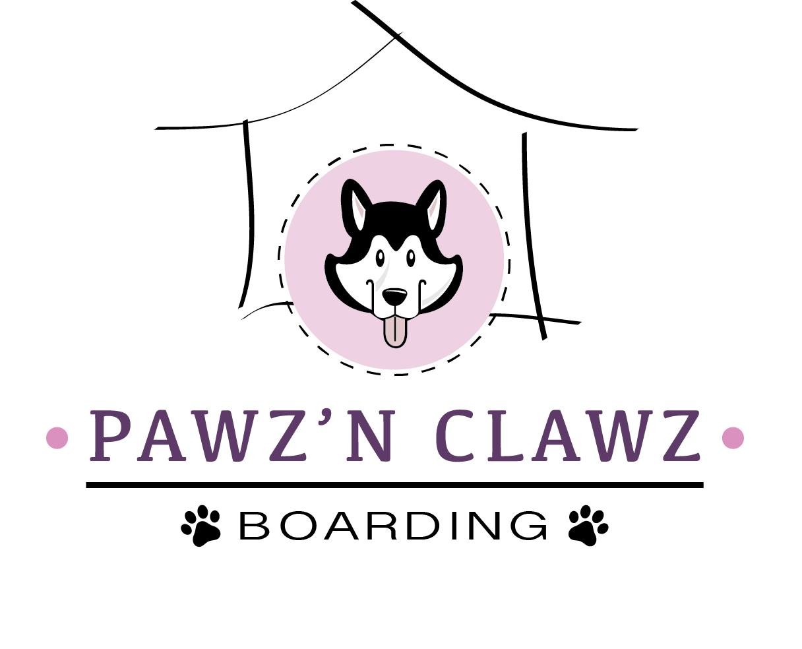
WAIVER & RELEASE OF LIABILITY
- I represent that I am the legal owner or agent for the above named dog/cat and I assume all risks, dangers and responsibility for my dog/cat during their stay at Pawz N Clawz Boarding Inc. as described in the correlating application form.
- I release Pawz N Clawz Boarding Inc., its staff, owners, representatives, and agents from any and all liability which I or my dog/cat may suffer including but not limited to injury, scratches, cuts, punctures, torn ligaments, sickness, damage or death resulting from participation in daycare, overnight boarding, or outdoor play.
- I understand that all dogs/cats are NOT monitored 24 hours a day, and injuries may occur from playing with the other dogs/cats, which include but not limited to bites, scrapes, scratches, cuts and sprains.
- I represent that my dog/cat is sociable and has not harmed or shown threatening behaviors towards any person or any other dog/cat. I understand Pawz N Clawz Boarding Inc. reserves the right to remove my dog/cat from the play area and place my dog/cat in a separate holding area should my dog/cat display any unwanted behaviors. I understand that if my dog/cat bites a Pawz N Clawz Boarding Inc. staff member the incident will be reported to the Health Unit and my dog/ cat information will be disclosed.
- I understand that Pawz N Clawz Boarding Inc. reserves the right to permanently remove a dog/cat from its daycare or overnight boarding facilities at any time.
- I allow Pawz N Clawz Boarding Inc. staff to contact my veterinarian or any other accessible vet clinic as deemed necessary should any injuries require medical attention. I agree that I am solely responsible for any medical costs in connection with veterinary or medical treatment acquired for my dog/cat plus any additional transportation fees.
- I release Pawz N Clawz Boarding Inc. from any liability should my dog/cat injure another dog/cat or person and accept medical and legal responsibility for my dog/cat actions.
- I release Pawz N Clawz Boarding Inc. from any liability should death of my dog/cat occur for any reason while in daycare or overnight boarding.
- I understand that my dog/cat will have access to the secure outdoor enclosures as well as out for walks on a leash. I agree to assume full liability should my dog/cat escape and runaway.
- I also agree to be financially responsible for damages caused by my dog/cat to the Pawz N Clawz Boarding Inc. facility.
- I represent that my dog/cat are in good health, and are current on all required vaccinations. We require all dogs be current on their DHPP, Rabies and Bordetella vaccinations. (Leptospirosis is not mandatory, but is recommended.) All cats require FVRCP, FELV and Rabies vaccinations. I understand that while my dog/cat are fully vaccinated that vaccines are not 100% effective and there is still a risk my dog/cat may contact a contagious virus/disease during their stay. To the best of your knowledge in the past 30 days my dog/cat have not been ill.
- Proof of vaccinations must be shown upon first visit and annual updates thereafter. The Bordetella vaccination can be administered using 3 different methods; Intranasal (3 day incubation), Oral (5 day incubation) and Injection (14 day incubation). Incubation periods must be followed prior to boarding at Pawz N Clawz Boarding Inc. Please inquire with your veterinarian. All pets must be free of fleas, ticks, and lice, and have not been ill with any known contagious viruses in the last 30 days. Pawz N Clawz Boarding recommend your dog/cat to be on an approved flea and tick prevention from the months June 1st to November 30th, but not limited to these months.
- I understand that while my dog/cat is fully vaccinated, that vaccines are not guaranteed and there is a small risk that my dog/cat may contract a contagious disease or illness. I agree that should this occur I am responsible for my own pet’s care and medical attention.
- I agree to allow 14 days waiting period after my dog/cat has had their vaccinations to allow the vaccines to reach full protection potential and to ensure my dog/cat has not had any negative reaction to the vaccines. Should I allow my dog/cat to stay at Pawz N Clawz Boarding Inc. less than 14 days after vaccination I understand that my dog/cat could be at risk of contracting a contagious virus/disease.
- I agree to disclose any previous or current medical issues or concerns of my dog/cat so that Pawz and Clawz Boarding Inc. staff can make a determination of suitability for daycare or overnight boarding.
- I agree that my dog/cat may be recorded on camera and its images may be used for Pawz N Clawz Boarding Inc. website, Facebook, Instagram or in marketing material.
- I understand that Pawz N Clawz Boarding Inc. is not responsible for any personal items left behind that may be damaged.
- I agree to pick up my dog/cat from doggy daycare/kitty daycare prior to closing time 6 p.m. Should I fail to do so, I understand that my dog/cat left after 6 p.m. will be charged an overnight boarding fee in addition to the daycare fee.
- Cancellations must be made 48 hours in advance during our regular periods. Please refer to cancellation policy during our peek times.
- I understand that overnight boarding services are charged on a 24-hour basis with drop off and pick up permitted only during hours of operation. Boarding pick up beyond 24 hours from time of drop off will be charged additionally at a corresponding daycare rate or may be subject to an additional overnight boarding charge if past 6:00 p.m. I understand that Pawz N Clawz Boarding Inc. reserves the right to refuse after hours pick up. An additional fee will be applied for any emergency after hours late pick.
- I agree to pay for any and all outstanding charges prior to or at time of pickup of my dog/cat. I understand that should I not have provisions for payment at the time of pickup for my dog/cat, Pawz N Clawz Boarding Inc. reserves the right to withhold my dog/cat and continue to charge for continued services and any additional fees until payment is made in full.
- In the event that you, your emergency contact, or any other person you have authorized to us in writing does not pick up your dog/cat up on the agreed upon departure date, you hereby authorize us to continue to provide boarding and any additional services at your expense. I agree that if my dog/cat is not picked up within 7 days of their scheduled departure date, my dog/cat will be deemed abandoned and Pawz N Clawz Boarding Inc. has the right to surrender them to the appropriate authorities. If you fail to pick-up your dog/cat for any reason, you release Pawz N Clawz Boarding Inc., its staff, owners, representatives, and agents from further liability and responsibility for your dog/cat.
With my signature below I herby certify that I have read and understand the agreement of Waiver and Release of Liability set forth by Pawz N Clawz Boarding Inc. I agree to abide by the regulations and accept all terms and conditions as set out. This waiver will be considered valid for one year after signing.

